API Sites for practice:

<https://apidocs.imgur.com/>

<http://restful-booker.herokuapp.com/apidoc/index.html>

https://github.com/Tahanima/restful-booker-api-test-automation/blob/master/src/test/java/com/restfulbooker/api/ApiTest.java

<http://coop.apps.symfonycasts.com/>

<https://developer.twitter.com/en/docs/twitter-api>

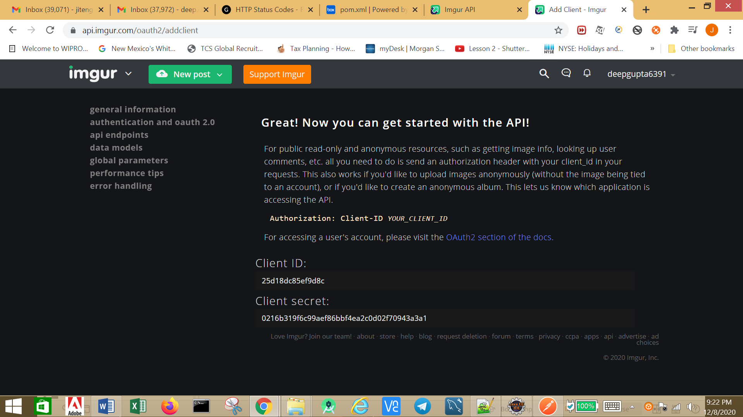

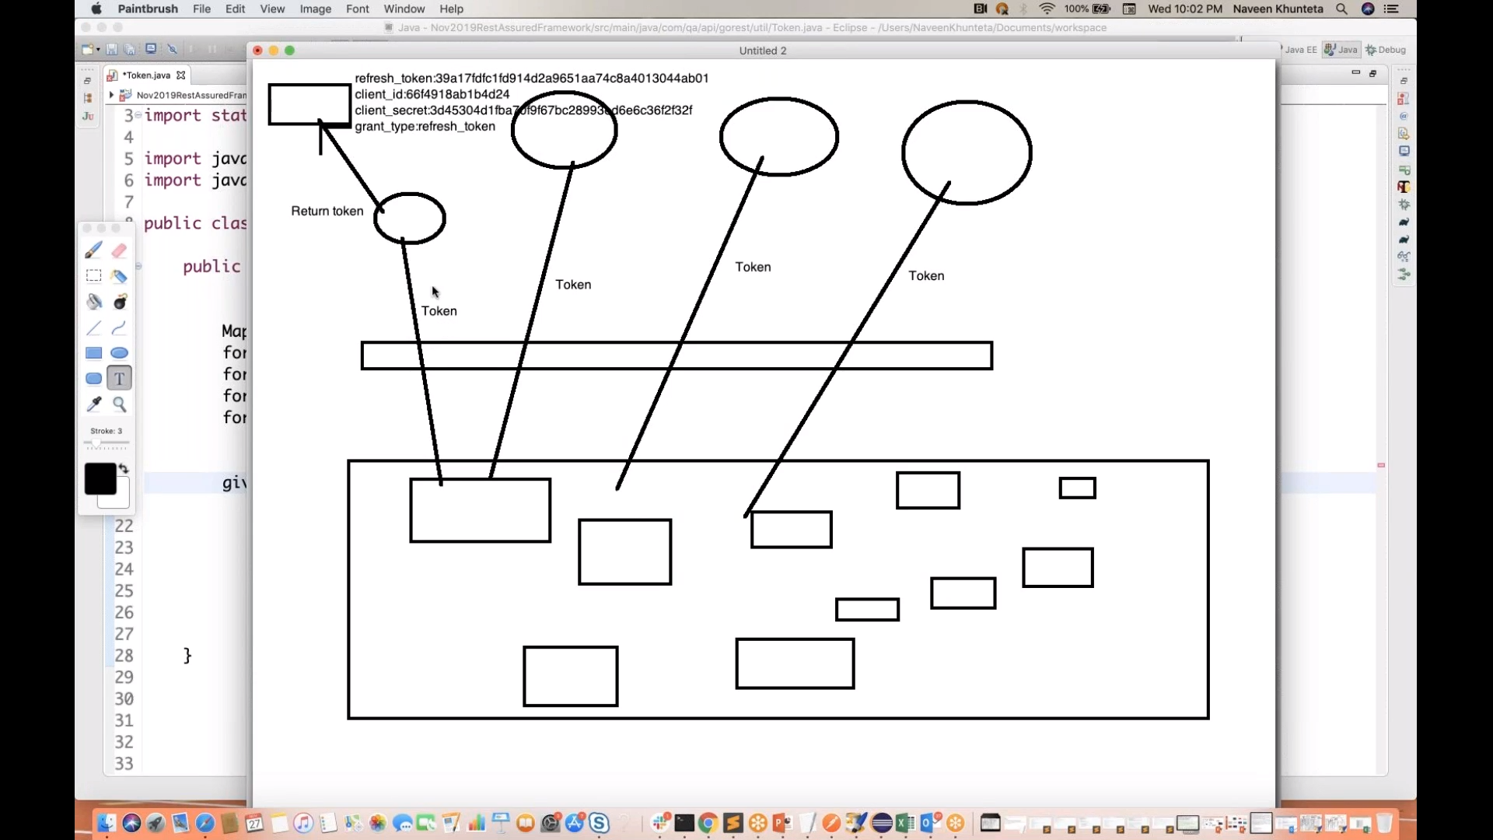

POST CALL: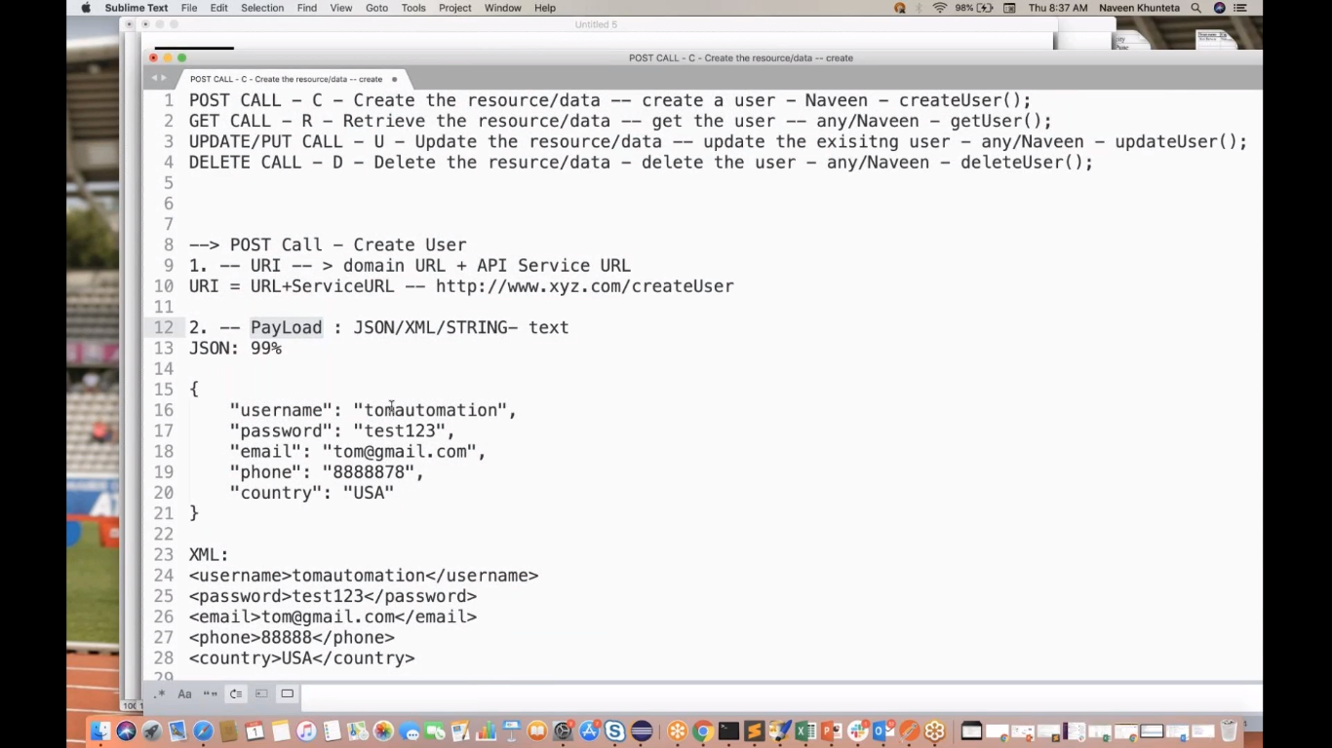

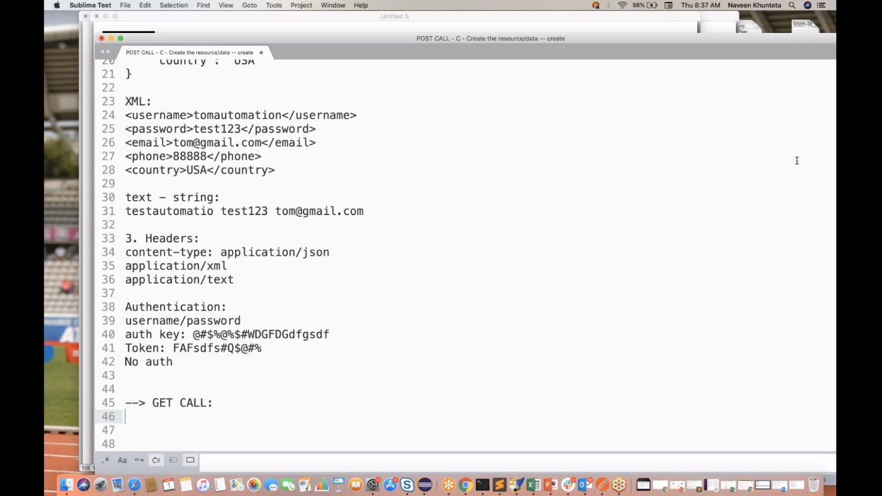

GET CALL:

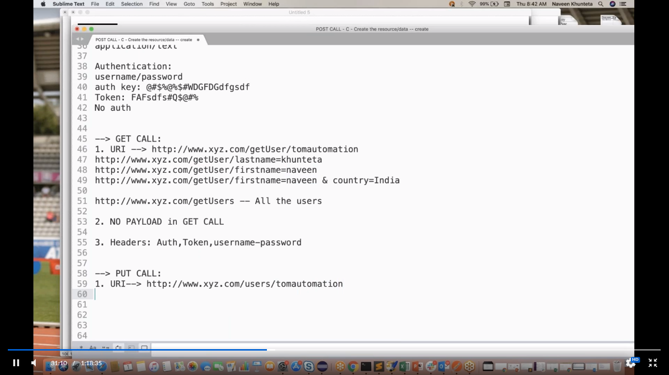

PUT CALL:

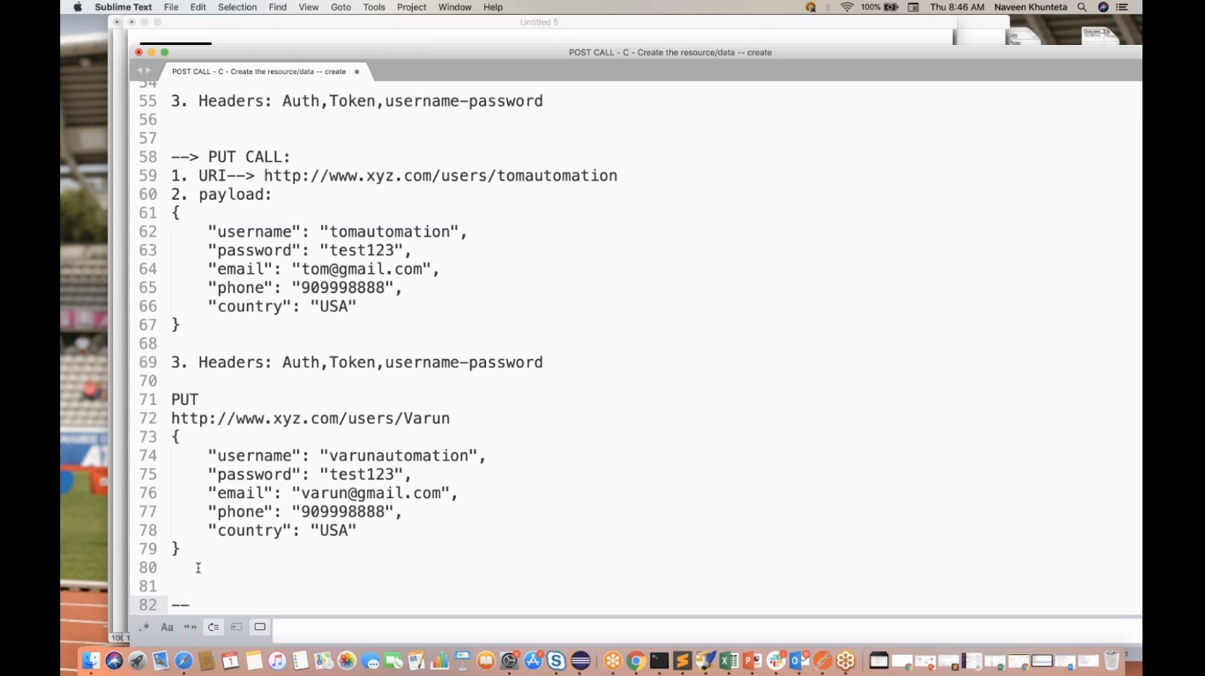

DELETE CALL:

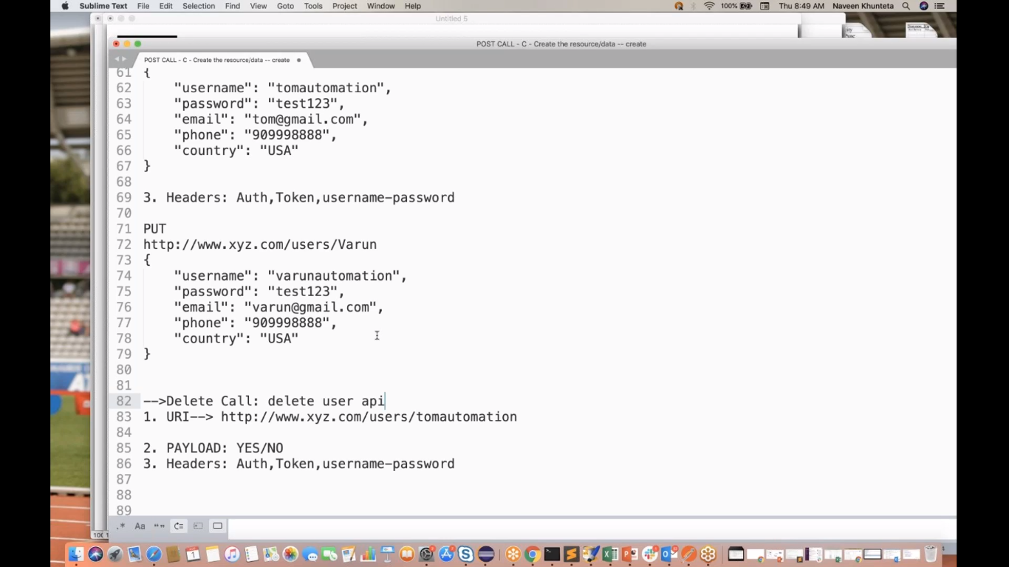

URL: https://gorest.co.in/

Access Token:88cb53d720e2f9c7e066f2ea6c9da98395886f1e39bb9b9ab48d33ad290da9cd

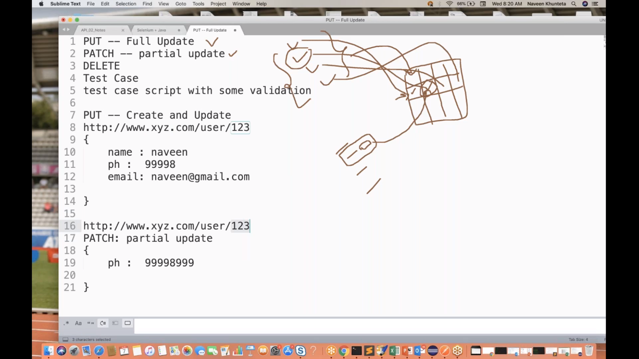

**POSTMAN:**

**A) Create a Request:**

1.HTTP Method

2.URI – URL+Service URL

3.Headers

4. Parameters – Path,Query Params

5. Request Body- JSON/XML

**B) Response:**

1. Body – JSON/XML/HTML

2. Status Code

3. Response Headers

4. Cookies

Parameters – Path, Query params

query param -- ?

* <http://www.xyz.com/users?name=deep>
* <http://www.xyz.com/users?name=deep&city=jersey>
* <http://www.xyz.com/users?name=deep&email=deeps@gmail.com>

Path param -- /

<http://www.linkedin.com/users/profiles/images?brokenImages=false>

JSON Body:

Content-Type: application/json

XML Body:

Content-Type: application/xml

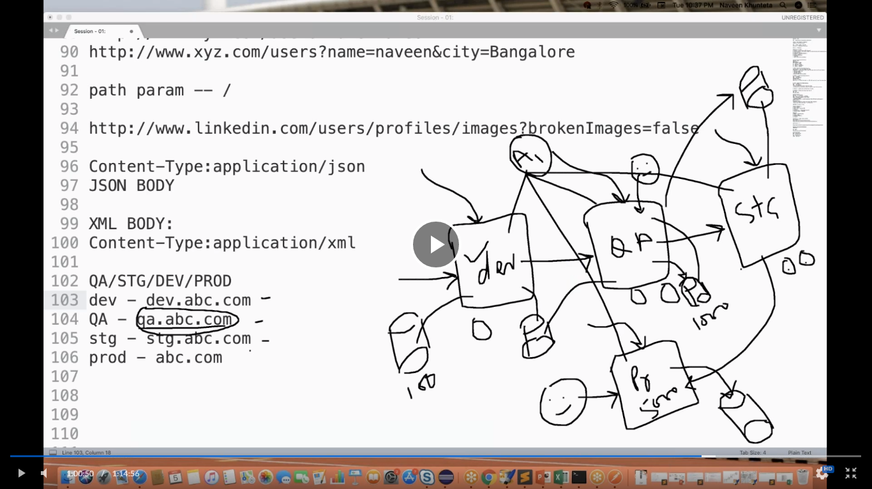

NEWMAN-CLI Runner for POSTMAN

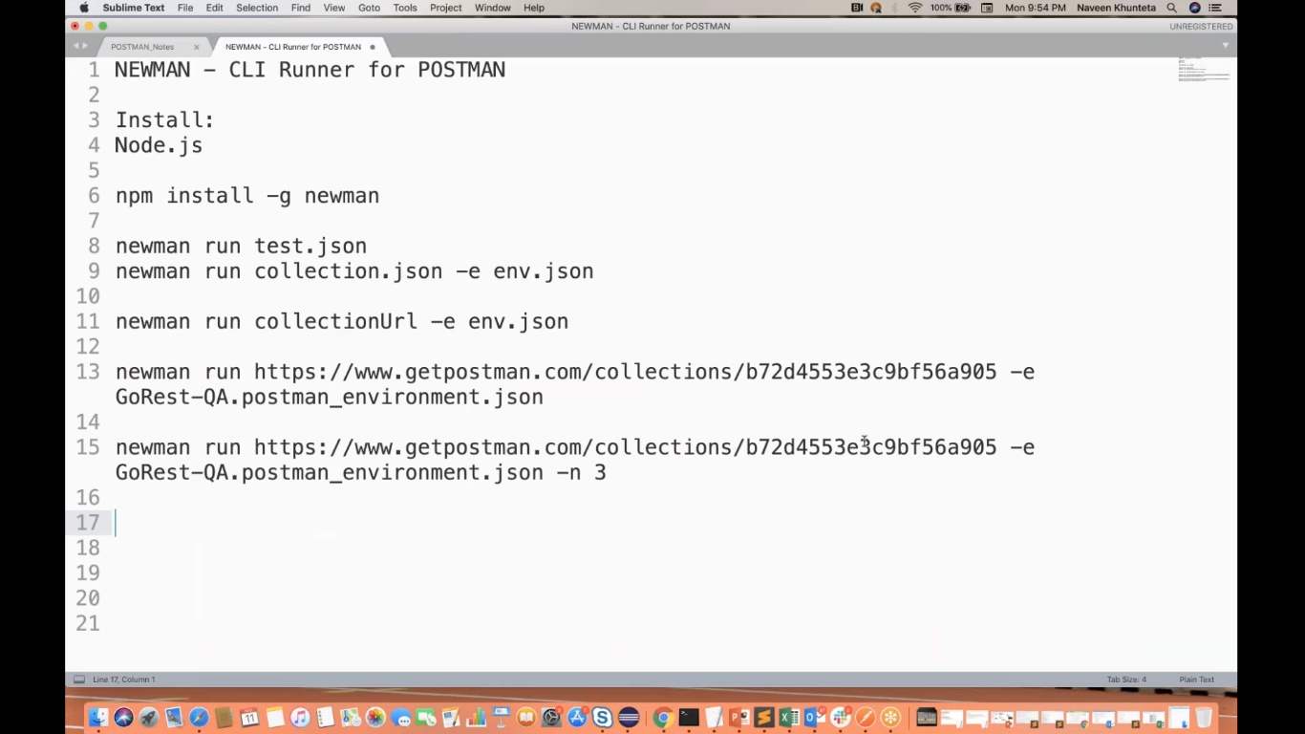

-r html( for generating html report)

-d data.csv

-d data.json(for data)

**Docker command for windows:**

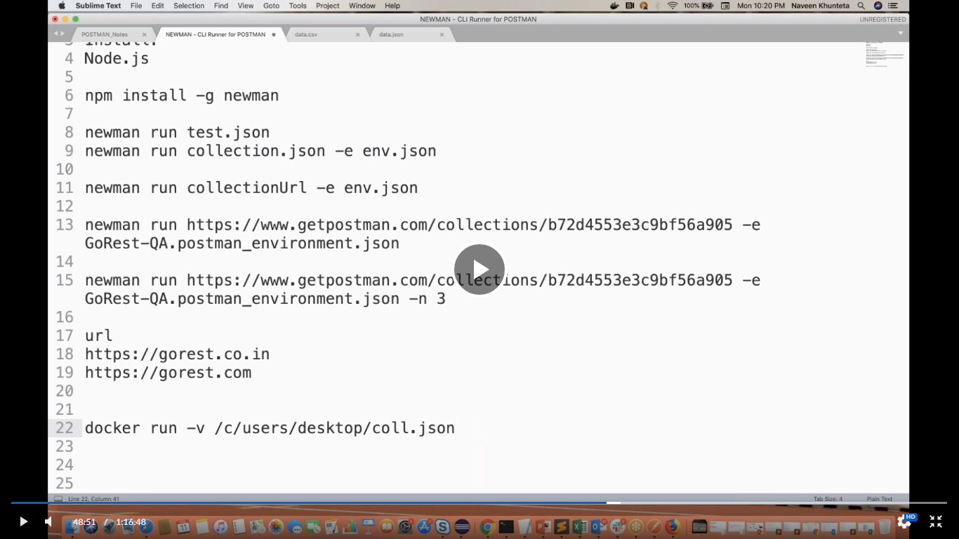

**Docker command for mac:**

* docker pull postman/newman:ubuntu(it will create a docker image)
* docker run –t postman/newman:ubuntu run “collection url”

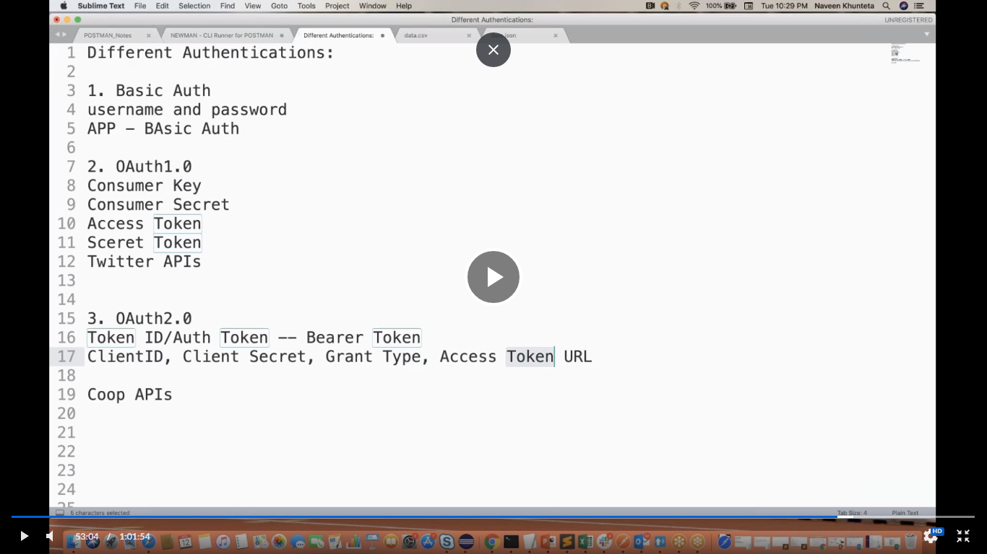 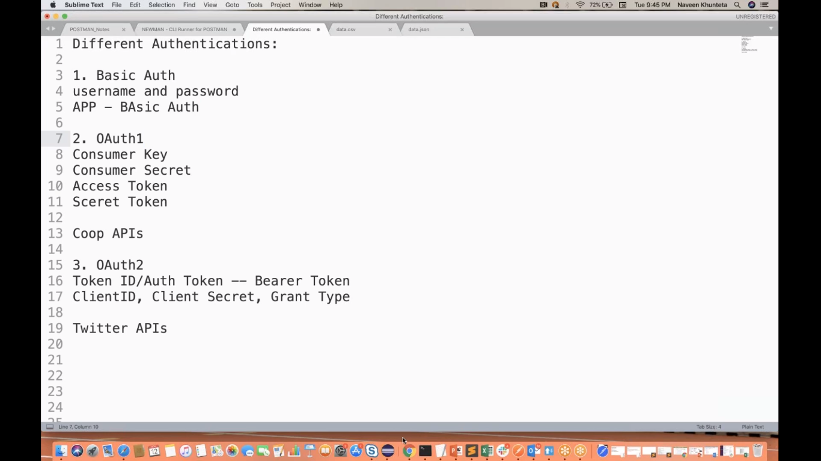

OAuth1:

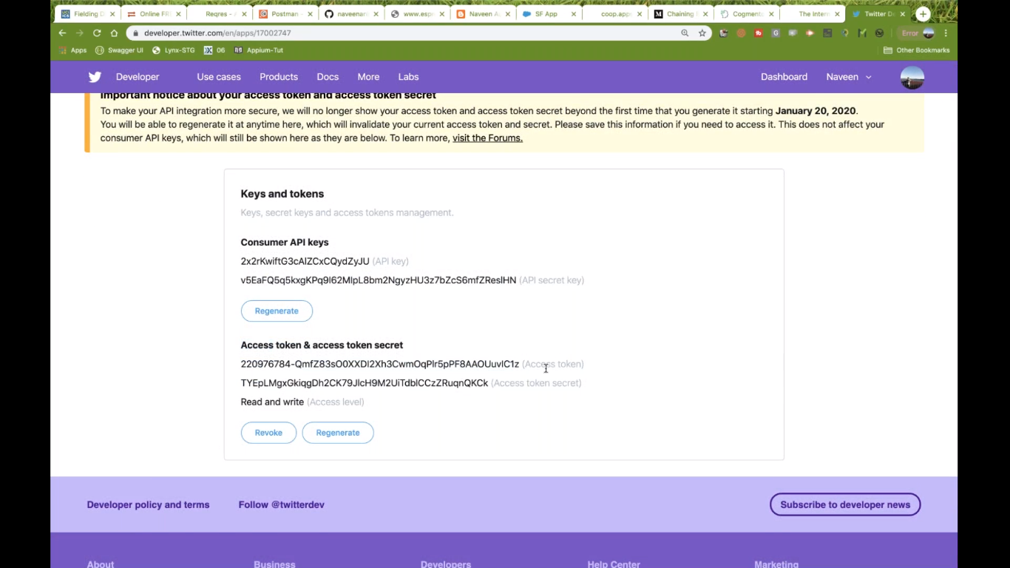 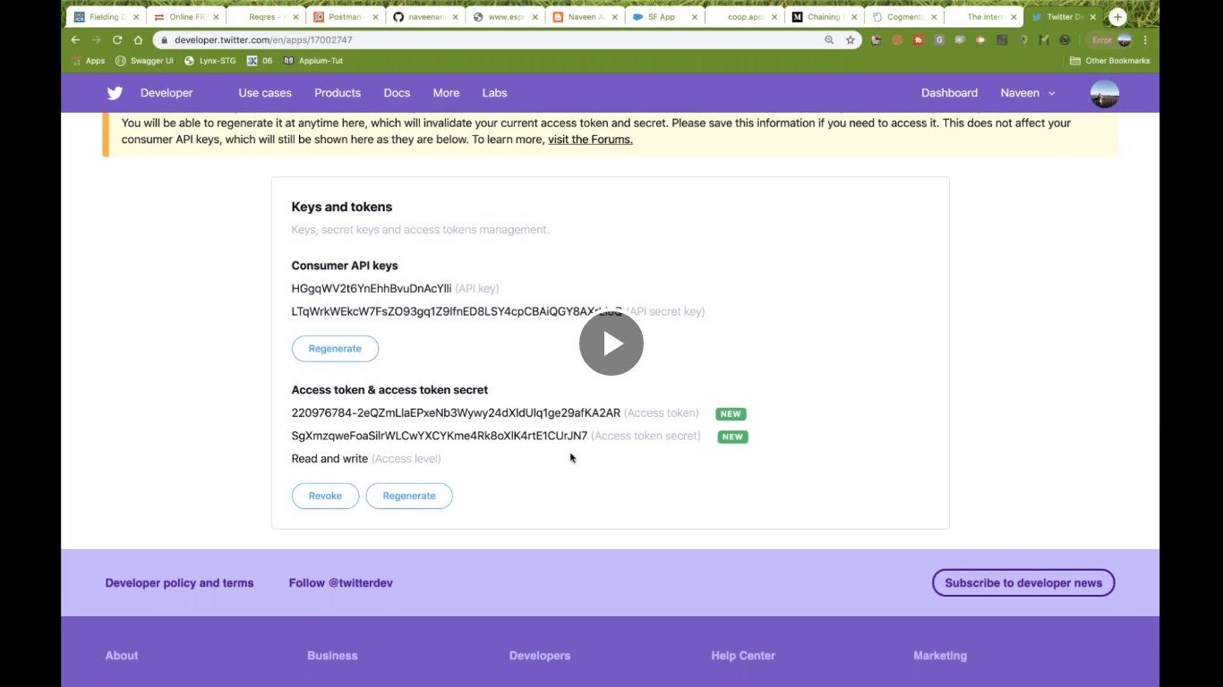

oAUTH2:

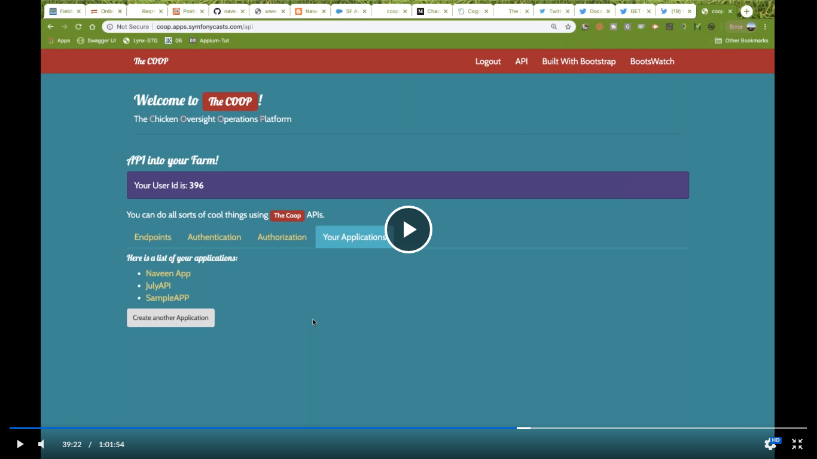

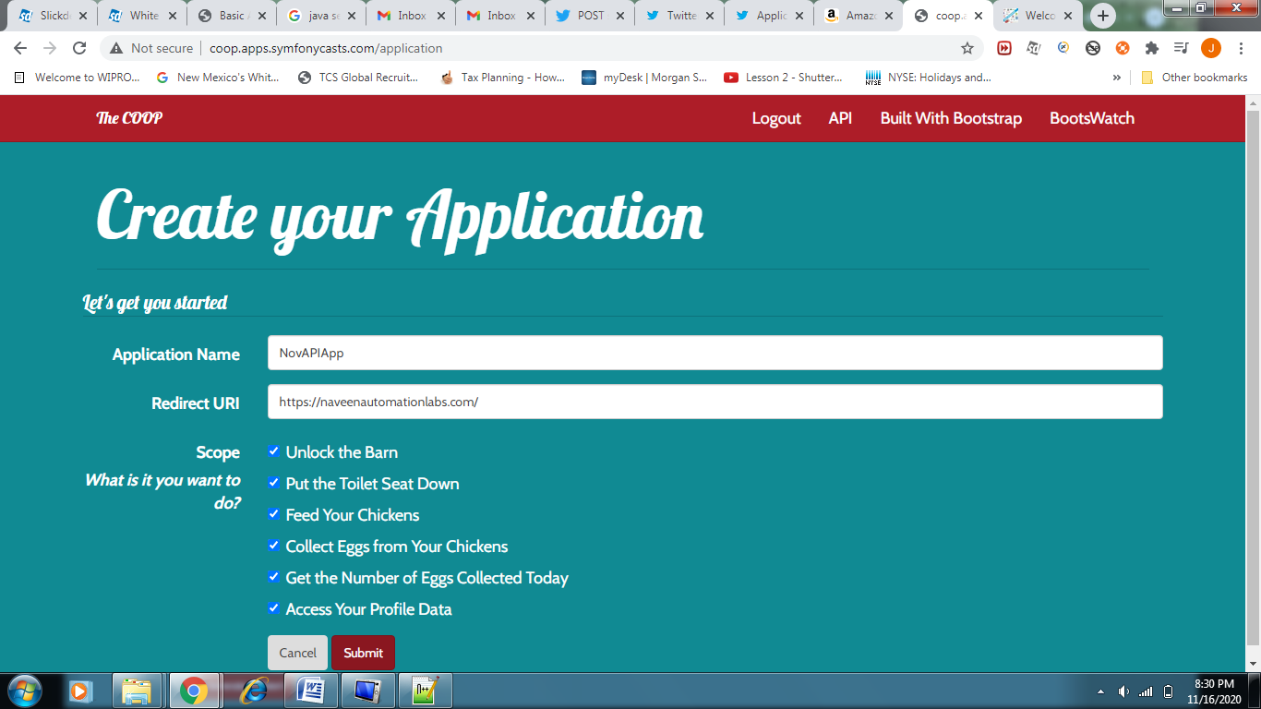

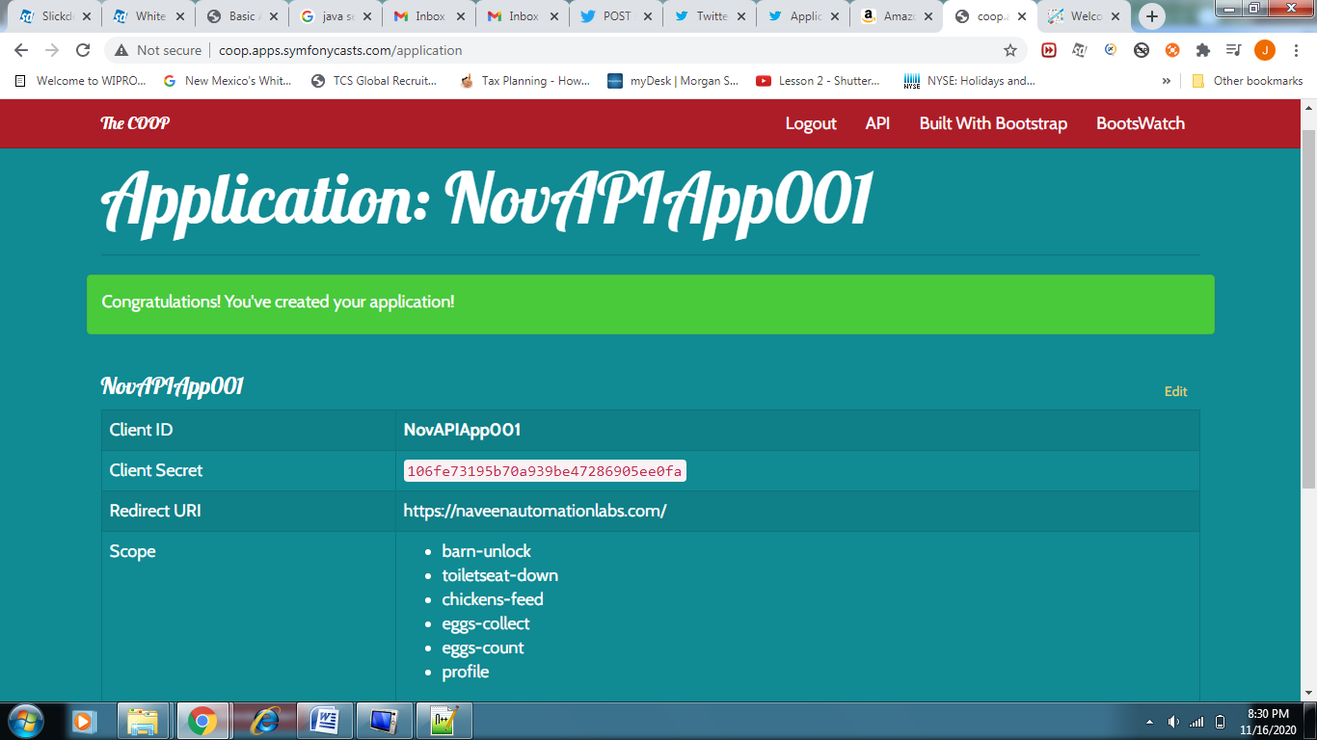 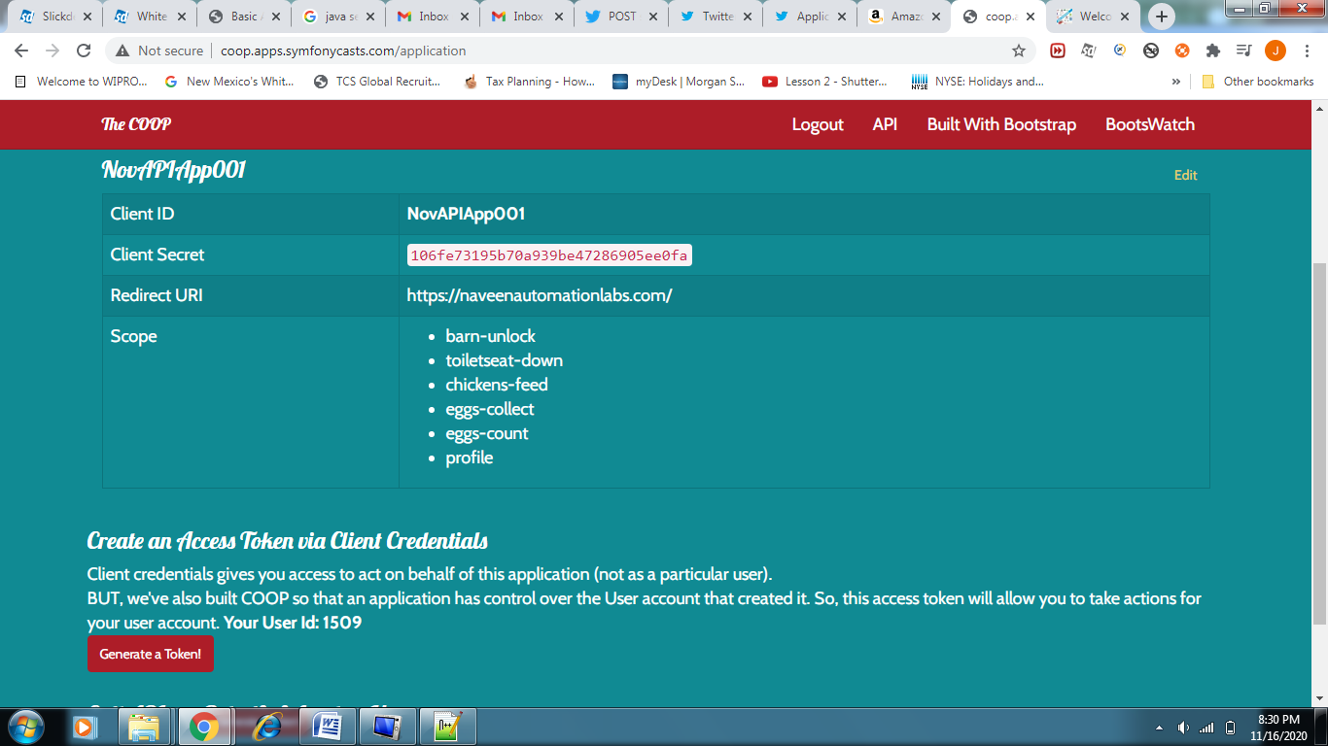

REST ASSURED:

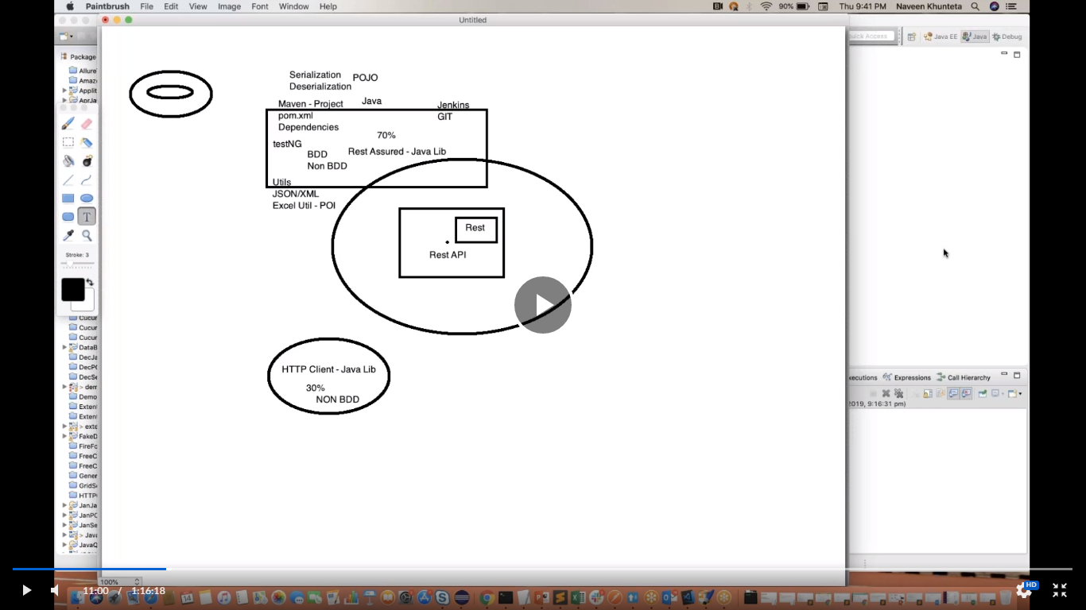

REST ASSURED Framework:

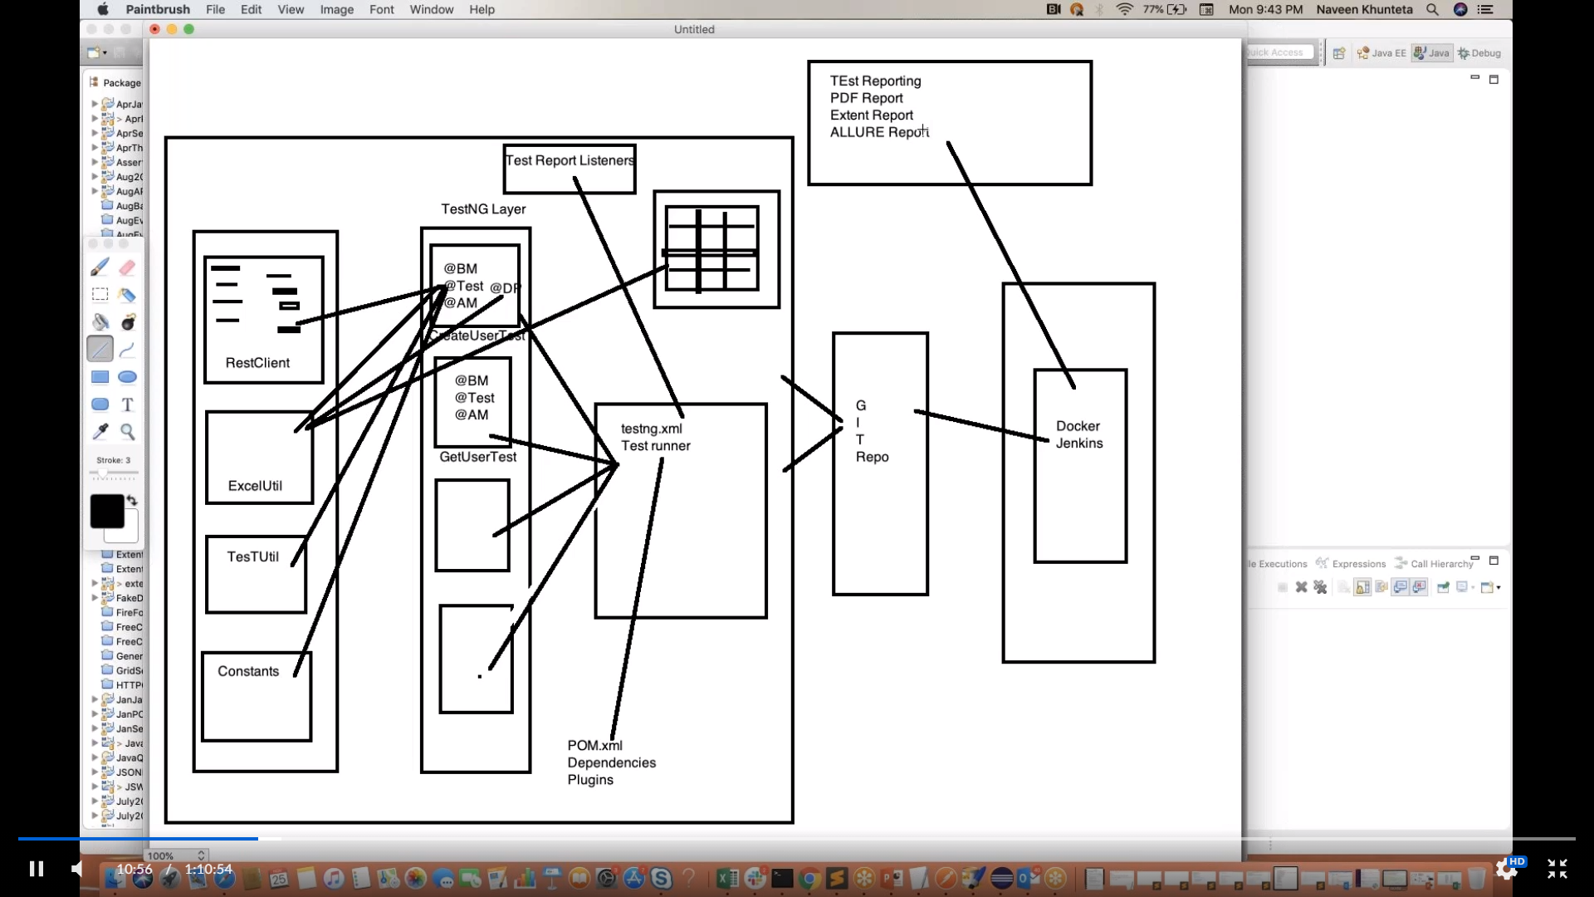

API Framework Post Pojo class user sample:

